# CHAPTER 1

# INTRODUCTION

## 1.1 Introduction

This project is about online exams system for university students. This software will be convenient for students and teachers. This software will be helpful for conducting online exams. If we look around the world in the present situation the covid-19 affect overall world educational institutes. It was so difficult for students and teacher to take exams through other social applications. So, we decided to create software for online exams.

We have created a system where the teachers import students from excel with the student details like name, roll number, department name, program, semester, and contact number, with temporary password. Through the email the student will be activate their account and can be changed their password to secure their account and restrict other users.

When the student login with their password then the software automatically picks the student details like department, program, current semester.

## 1.2 Web Application

Web is a highly programmable environment that allows mass customization through the immediate deployment of a large and diverse range of applications, to billions of users. There are two basic main component of the modern website one is web application and web browser and available for both and separately at no cost.

Web browsers are software applications that allow users to retrieve data and interact with content located on web pages within a website.

## 1.3 Categories of Web Application

### 1.3.1 Centric Web Application

A centric web application is a static html documents which is stored on web server that is directly sent on the request of the client. With the help of respective tools web pages are updated manually. This type of applications is very simple and taking less respond time.

### 1.3.2 Interactive Web Application

Interactive web application is also simple and fast. In this type of application, the links and web pages are created according to user input. It is consisting of selection forms, radio buttons, and selection menus etc.

### 1.3.3 Transactional Web Application

This type of web applications is more collaborative. The user can modify it.

### 1.3.4 Work-Flow Base Web Application

The work-flow web application is an application in which handling workflow between various companies, public or private authorities. The common example of that type of applications is b2b e-commerce.

### 1.3.5 Collaborative Web Application

Collaborative web applications are used in group communication like chat rooms, online learning websites. In this type of applications, the information would be share with option. Common example is Wikipedia.

### 1.3.5 Portal Oriented Web Application

In this of web applications in which the single access point to sort out distinct source of services and information’s.

### 1.3.6 Ubiquitous Web Application

In this type of web applications produce a customized service any time for any device.

### 1.3.7 Knowledge Base Web Application

Knowledge base web application is used to provide knowledge for machine and human both.

## 1.4 Existing System

In current situation there is no online system where the students can attempt exams, test, quizzes. So, in this system students can attempt exams online from everywhere. Simple and easy method to access the system. It is so difficult and long process on other social systems to attempt online exams like in emails WhatsApp etc. We faced in many problems in existing system as follow.

### 1.4.1 Performance

In the existing system there is many problems like clicking pictures from answers on camera and change to pdf or word file sometimes create a large a large file which cannot send through WhatsApp emails etc. And time consuming in existing system.

### 1.4.2 Security

The most important and necessary point of every organization is security. In the existing system the security of information is not strong, in existing system due to wrong address the paper cannot reach to required user.

### 1.4.3 Complex Processing

In the existing system it is a long process to attempt exam and checking the result manually. It is time consuming in existing system.

## 1.5 Online Exam Conduction System

Online exam conduction system is a software in which the conduction of online exams it is simple and easy method to login and access this software. In this software the teacher of every department can upload the question paper while the students can be attempting the paper at the given time. After attempt, the exams the result will be show on the spot. It may help to both students and teachers simple and quick access to this software.

### 1.5.1 Services of the Project

The software provided exams system which make the software suitable for exams and other activities like quizzes, tests, etc.

### 1.5.2 User Account

User account can access only registered users. There is four users account as follow.

### 1.5.3 Admin Account

Admin can register itself by registration system.

### 1.5.4 HOD Account

The HOD account can be registered by the admin account. The admin will be register through the admin.

### 1.5.5 Teacher’s Account

The teacher account will be register through the HOD. The HOD can register the teacher’s account.

### 1.5.6 Student Account

The student account can be registered by their teacher.

### 1.5.7 Registration

The admin manages and register the HODS account, the HODS manage and register the teacher accounts, the teacher manages and register the student account and while the students registered by itself using email and password.

### 1.5.8 User Login

First the student needs to register the account then they can login to the system. When the user login then the system automatically shows to user their subject course.

### 1.5.9 Admin

Admin handles and control the whole system. Admin is the main user of the system. The system will be controlled through admin panel which will only be available for admin only. The admin has some rule which for other users does not have. Following some has some features for admin.

### 1.5.10 Admin Login

After the registration when the admin login the admin panel will be show to the admin. Which the data of the admin will be already stored in database table. The admin must secure their account using username and password in order. The purpose of secure their account that no one can access their account. The admin needs to logout when the admin work is finished so, the admin panel will be secured.

## 1.6 Objectives of the Project

1. The objectives of this project are to remove the educational problem of students during online exams. For example, through other social media networks like WhatsApp, learning management system etc. There are many problems during exams that the student has faced. It is more convenient for students and teachers.
2. The project aims to present such system that is more user friendly such as time maintenance, result on time, upgrade students, stored student record.
3. The information of the student is completely stored in database. Where only authorized user can access this information. Every user has unique username and password.
4. When the user login to the portal then system automatically show this program with subject.
5. The main objective of the online exam conduction system is the student attempt the paper in specific time. The paper checked through this system automatically and the result will be show on the spot.

# CHAPTER 2

# TOOLS AND REQUIREMENTS

## 2.1 Requirements

In this chapter we will discuss the basic requirements of online exams conduction system. The main purpose of this proposed system the students can attempt and access easily this system. It is so simple system instead of previous system like WhatsApp and other social networks. This proposed system is web-based system which will be used by the university students for online exams.

## 2.2 Functional Requirements

### 2.2.1 Registration

In the registration the admin, head of department (HOD) and teacher register itself while the student will be registered by the teacher. In this web application the information of the users must be stored in database.

### 2.2.2 Logging In

The system must be able to identify user based on the username and password who is the member of database.

### 2.2.3 Admin Access

The system must be able to provide admin accessibility to import department with programs, semesters and add, delete, and edit it. The admin will be able to activate HOD, S account.

### 2.2.4 HOD Access

The system must be able to provide accessibility to activate and deactivate teacher’s account. HOD can import students. In the HOD access the HOD can insert courses of every semester and promote students by semester. The HOD import date sheet and edit and update it.

### 2.2.5 Teacher Access

The system must be able to provide accessibility to teacher to import student email with detail and upload paper with its instructions and check paper. Also submit the result of the paper.

### 2.2.6 User Access

The system must be able to provide accessibility to student to activate their account and change/forget the password of their account through email.

## 2.3 Nonfunctional Requirements

### 2.3.1 Performance

Database changes must take less time.

Login validation is simple and taking less time to validate.

### 2.3.2 Security Requirements

The communication must be encrypted between data server and user.

## 2.4 Software Attributes Accuracy

The system must carry out the basics of the online exams to perform aims of the users.

### 2.4.1 Efficiency

Various resources are used to carry out the proposed work efficiently.

### 2.4.2 Flexibility

The system should be able to add some additional features.

### 2.4.3 Integrity

The system should be able to secure users information.

### 2.4.4 Portability

This system is compatible with any operating environment for example window XP ,7,8,10 etc.

### 2.4.5 Usability

The system must have to provide ease of use to any type of user.

### 2.4.6 Testing

For the work satisfaction this application must be testable.

### 2.4.7 Changeable

The application ensures flexibility.

## 2.5 Tools Used for Development

There is a lots of development tools and languages are available in the world. For the development of web application client-side languages and server-side languages. So, we will discuss various client-side languages and server-side languages which is used for the development of proposed online exam conduction system.

### 2.5.1 Client-Side Technology

A client-side technology is the type of technology or languages in which no connection required to connect with server also run on client side. This type of technologies/languages used for development of proposed application as follow.

* **Markup Languages**

It is a language in which is used to mark text, images, and web pages etc. It is used for instructing the software to show text in specific format and style. To develop a web application hypertext markup language is best. Basically, it is made from two words hypertext and markup. Hypertext is providing to other pages while, a markup means proper format/style to web pages, text, and images.

* **Client-Side Script Languages**

The basically language which is used for client-side language is java. It is used for both client and server side, but we can used it in client side, because it is understandable and easy to learn. Java script is encoded with many other languages like java, C++ and c. In client-side scripting language we can also use java script.

* **Style Languages**

Style language is generally used for colors adding, font styles, we use CSS cascading style sheet to merge web documents. To make our web pages or web application well design, attractive we use CSS. CSS provide the basis for separating documents contents from document presentation, and adding features such as font style, colors and layout.

### 2.5.2 Server-Side Technology

Server-side technology is a technology which is run on server side. And we used it for the development of online exam conduction system which is the following.

* **Web Server**

It is a program which is run on server and produce resources to the user/client. When a client request for any resources it take http request and proper response to client. When a client enters domain URL in browser then web server immediately searches related files. If our relevant file is available, it shows in our browser if it is not available it shows 404 not found. One of the open source servers is apache. Many free web servers by apache’s company is available which is used easily with MYSQL and PhP. But the server, which is widely used and understandable, easy to learn is Wamp and XAMP.

* **Server-Side Script Language**

Server-side script is a method used in web development that involves placing a script on a web server that generates a custom response to each client request on the website.

It is widely used language which is used widely on the world because it run on server and powerful language. It is also known as preprocessor hypertext. In php we must have to used web server Wamp server because its run only on server side.

* **Database Solution**

Database is used for stored the data. So, to store the data we must use database management system (DBMS). There is different database software such that SQL, MYSQL, oracle, MSACCESS and db2 but, we used MYSQL software in our project.

### 2.5.3 Hypertext Markup Language (html)

Html hypertext markup language is a standard language which is used for developing web pages. Many developers used html language to develop own websites. Html is used for creating digital files which is shown on the worldwide web. It is an understandable language easy to learn. Html used some tags closing tag and opening tag, both have the same text. The opening tag is <html> while the closing tag is little bit different than opening tag. The closing tag is addition of forward slash </html>.

The <IMG> tag is used for showing images. Html can create static, plain pages. HTML is default in every window so we do not need to purchase other software’s. HTML is supported language by every software so every software can support by html.

### 2.5.4 CSS

CSS stand for cascading style sheet. CSS provide internet pages. It can handle the whole format of texting such that font size, color of the text, the column resizing and laid out and background images etc. CSS can make a web page responsive. Using the CSS, we can give better presentation or organization to our html. CSS can save and control the layout of multiple pages at a time. CSS is combined with html. It provides load faster, mean faster download times. In CSS if we write on CSS rule so, it does not require write a tag again and again.

### 2.5.5 MYSQL Database

MYSQL is open source free software database. It is mostly 2nd worldwide used database. MYSQL is secure database where developers can store data securely. It is easy and understandable use database. This is a huge subset to ANSI 99 and is also called an extension. MYSQL is a relative database management system, and these tables are connected to other coaches to access database tables.

The MYSQL database is connected to Laravel via the open database driver ODBC. This driver is used as translation layer among the application and database management system. This application relates to a driver as well as it uses ODBC. The function calls processed by OCBC collects the inputs of MYSQL server request and a similar request becomes the result of the request. It may be also revised the necessary to support MYSQL syntax.

### 2.5.6 Connection of Database with Laravel

During creating the project in the Laravel we use Laravel commands (composer create-project –prefer-dist. Laravel/Laravel test) that write in Laravel composer to create a project We must need to create or design database for project. After that to save the data securely the database connectivity must be required to the project. If the project is to be created in Laravel then the file is already an extension file .env. To open the .env file we can only change the database name in our case “root” the password is remaining as a null. The Laravel .env provide a functionality the database for other configuration settings such that email etc.

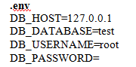

### 2.5.7 Apache

Apache is a web application server which provides html pages, multimedia and cascading style sheet on internet. Apache is published by apache software foundation, a team of developers, programmers which consist of 20 members in 1995. Apache is supported software of many languages such that PERL, python, TCL and PhP. Apache can support a thousand of a request at a time. And it is available on world wide web. The request and response mechanism in apache through a http protocol securely. It is popular software because it is available on world wide web open source for everyone. Request and response mechanism in apache are through a file extension. When the file extension is .php so, it forward request to PhP engine. And if the file extension is blade PhP then request is further forward to Laravel engine.

### 2.5.9 XAMPP

XAMPP is software which is used in PhP language. It is software which has its own server and no internet connectivity required. It is used in PhP language because PhP work on the bases of XAMPP. XAMPP stand for x mean cross platform, a stand for apache, m stand for MYSQL, p stands for PhP and p stand for PERL. XAMPP has own local server known as local host. We just need to install XAMPP and we are ready to use our system for local development. From XAMPP configuration we can enable MYSQL, PhP, apache, etc. In the XAMPP apache will be used for http server. MYSQL is used in XAMPP for database and php used as scripting language while PERL is to use for programming language.

### 2.5.9 PhP

PhP is a server-side scripting language which is used for creating web pages embedded with html. PhP is also known as “hypertext preprocessor”. PhP is open-source free software no cost available on world wide web. PhP is supported more than 20 databases and can provide information based on its input PhP will be used in different platforms such that Linux, Microsoft windows etc. It was created in 1994 by Rasmus Lerdorf. High professional developers use PhP because it is secured and easy to learn.

### 2.5.10 Laravel

Laravel is a framework of PhP. It is an open source freely available on web. Established by Taylor otwell for the development of web application. Laravel is an object-oriented language so, it is easy to learn. Laravel follow MVC (model view controller) design pattern. Laravel save our time instead of if we are planning to build a website. Laravel is secured from several attacks. Laravel provides namespaces and interfaces which help us to manage resources. Model view controller provide us the facility to write code. Laravel is supported with many features. Such that modular packaging system. Laravel is popular PhP framework software which is used for both large and small web development projects. The reason of popularity is its features and open source high secured.

* Laravel framework provides high class security.
* Laravel is capable with best performance of web application.
* Laravel provides faster and better way functionalities.
* Laravel provides powerful authentication.
* Laravel is open source free of cost.
* Laravel provide blade templating to its users (pre-defined templates).
* Laravel is facilitates with MVC architecture, it improves performance of our web application.
* Laravel provide integration with mail services.
* Laravel is facilitates with linkage database.
* Laravel provide migrate command facility.

# CHAPTER 3

# METHODOLOGY AND DESIGN

## 3.1 Agile Process

The agile process is incremental process, in which small and updated publications of the proposed system are created and delivered to customer within two, three weeks. The developer actively engages users during software development to get feedback on any changing needs. The agile process begins with the effective and it is dilatory that the last product can be used. The expectations of the customers of this project team are clear activities. Once the work begins, the teams plan, implement, and examine a process that drives the process. Continuous collaboration, with team members and both as the achievement of the project, is the key to making fully informed decisions.



### 3.1.1 Agile Software Development Principles

1. **Customer Involvement:** The customer must be involved in the entire process of the development of proposed application. The customer will have to provide the new system requirements.
2. **Incremental Delivery:** The software must be developed in incremental method, according to the customer needs. In the incremental delivery the developer must have to include the new requirements of the customer in each incremental model.
3. **People Do Not Process:** The capabilities of the development team should be re-evaluated, and all members of the team should be free to design and develop their own way of working without using the old process.
4. **Embrace Change:** The system should be able to adjust the changes as well as the requirements.
5. **Maintain Simplicity:** To maintaining the software development work and the development process itself there should be a simple.

### 3.1.2 Agile Model Process

**1. Requirement Analysis or Planning:** Each software development model begins with in analysis which a user discusses the product requirements of the customer. The main purpose of this initiative is to explain the requirements in detail. The participant should clearly understand their tasks and implement every requirement.

**2. Designing:** At this stage, the software developer develops a simple architectural design for the proposed system. Team ranking, task scheduling, technology choices and limitations are all explained here.

**3. Implementation:** Programmers memorize coding and start them with all the requirements in mind. The actual increments here are tailored to the customer requirements.

**4. Review:** This step examines the source code, which intends to detect and correct errors that occur during system developed. It also increases the quality of the whole system.

**5. Testing:** At this stage, the finished product is tested and compare with the requirements. The code is also checked here. If the system fails, it will be return to the back programmer for correction. Testing process is ongoing until the system workflow is constant.

**Agile process model**

Figure 3. 1 Agile process mode1

## 3.2 Flow Chart

A flow chart is a diagram in which a diagrammatical representation of a specific application. The flow chart shows the steps as different types of boxes and their order by connecting the boxes with arrows. Flow chart is consisting of various types of boxes. Flow chart is basically use for planning the design of a different computer programs. And can be used for other tasks.

### 3.2.1 Types of Flow Charts

**1. Documented Flow Chart**

Documented flow chart shows the flow of electronic document and paper between various units of businesses. This flow chart shows the tools that help the developer to understand the work inside an organization. This type of flow charts must be read from left to right to shows the flow of documents.

**2. Data Flow Charts**

This type of flow chart is also called a data flow diagram. This type of flow chart represents the flow of graphical data within any information system. It shows control over the flow of data in the system.

**3. System Flow Chart**

This flow chart represents how the data flows into a system. These kinds of flow charts the integrated symbol to indicate that what is happening in different parts of the data requires a system. System flow chart also represents control over the physical level in the system.

**4. Program Flow Chart**

Program flow chart is used to describe how to work within a modern system. This flow chart is uses four basic symbols when constructing a complete flow chart, complete start, processing, decision, and end.

Figure 3.2 Program flow chart

## 3.3 Data Flow Diagram (DFD)

A data flow diagram is a diagram in which represent the flow of a data from inside and outside of a system. A business information system uses a data flow diagram to represent the flow of the data. Data flow diagram is shortly known as DFD. Data flow diagram describes the methods involved in transferring data from input to file storage and reporting generation imports. Data flow diagram is divided into two diagrams logical diagram and physical diagram. The logical DFD describes the flow of a data through a system to perform certain functions of a business, while the physical DFD illustrates the implementation of a logical data flow.

The DFD notations uses following four major symbols:

* Processes: the actions that the system performs are called actions. Processes are in use and manipulate information’s. These types processes represented with a rectangle.
* External entities: external entities are also called source or sinks and terminators as actor. External entities produce and use the data that flows between system being diagrammed and entity. These data flows are DFD inputs and outputs.
* Data flow: data flow is the movement of data between processes, external entities and data store is represented by an arrow. This data can be electronic, written, or oral. The input and output of the data are label based. The arrow represents the direction of data flow.
* Data store: data store does not create any operation, but the data is easily accessible for later access. The input entering the data store includes information or operations that modify the stored data.

### 3.3.1 Advantages of DFD

* DFD provide a practical overview and system limitations.
* Discuss current system knowledge with simple visual representations to stakeholder.
* DFD provide a functional error to the systems.
* By technical and non-technical audiencias DFD is easier to understand.
* DFD provides a straightforward graphical technique that is easily recognizable.

### 3.3.2 Types of DFD

DFD has three major types.

* **Context Diagram:** The context or 0 level DFD is also called the form of context. Context or 0 level DFD is designed for an abstract view, in which the system is shown as a single process with its relationship with external entities. It is representing a top-level view of the proposed system.
* **Level 1 DFDs:** In this level of DFD the context diagram is melts into multiple processes. At this level we highlight the key functions of the system and disrupt the high level DFD process in all processes.
* **Level 2 DFDs:** Level 2 DFDs is used to shows decomposed level 1 DFD process. Also used to point out the necessary systems functioning details.

**Context Diagram for Online Exam Conduction System**

Online exam conduction system consists of four external entities such as the admin, HOD, teacher and student. The context diagram of OECS is given below.

Student

ONLINE EXAM CONDUCTION SYSTEM

Teacher

HOD

Admin

Figure 3.3 Context diagram of OECS

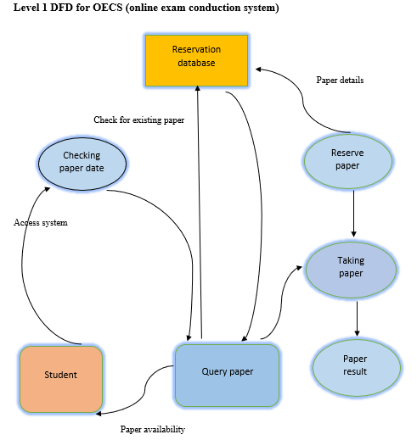

Figure 3. 2 Level 1 DFD

## 3.4 Entity Relationship Diagram (ERD)

ERD entity relationship diagram is used to represent the relationship among the entities and attributes. ERD is the graphical representation of a database system. For a good database designing it is important to have an ERD. ERD and DFD are combined that show the contents of data store. They help us see how data is connected in general.

**Entity**

Entity is object/thing which exists in database administration. Entity can be a place, thing, person where data can be stored about these entities.

**Attribute**

Attribute is the properties of an entity. These entities have many attributes for example student is an entity while its attributes are student name, student department, student semester, student roll no, student address.

**Relationships**

A relationship is natural association which is occur between one or more entities. There are four common relationships as follow.

One to one relationship

One to many relationship

Many to one relationship

Many to many relationship

## 3.5 Key

Key is the set of attributes which is used to define special entity instance type of entity.

### 3.5.1 Types of Key

**Super Key:** It is a group of single or multiple keys that indicate rows in a table. It may contain additional attributes that are not required for unique identification.

**Candidate Key:** It is a set of attributes that indicate the uniqueness of the tuples in table. A candidate key is a super key that does not contain repetitive attributes. The candidate has more than one key in the table but only one primary key.

**Primary Key:** Primary key is a group of columns or column that identifies uniquely each row in that table.

**Alternate Key:** It is a column or a group of columns in the table that indicate each row in that table.

**Secondary Key:** A secondary key is an unrecognized/un-identifying column or combination of columns which is used to identify rows in a table. A secondary key is created in a field that we would like to list in the quick search list.

## 3.6 Entity Relationship Diagram (ERD) of – (Online Exam Conduction System) OECS

Entity relationship diagram (DFD) our proposed system/application is consisting of different number of tables. Some tables are dependent, and some are independent. These dependent tables are linked together though a database key. Follows are some tables ERD.

**Tables with Relationships:**

**Dependent Tables with their Attributes:**

Table 3. 1 Dependent tables with their attributes 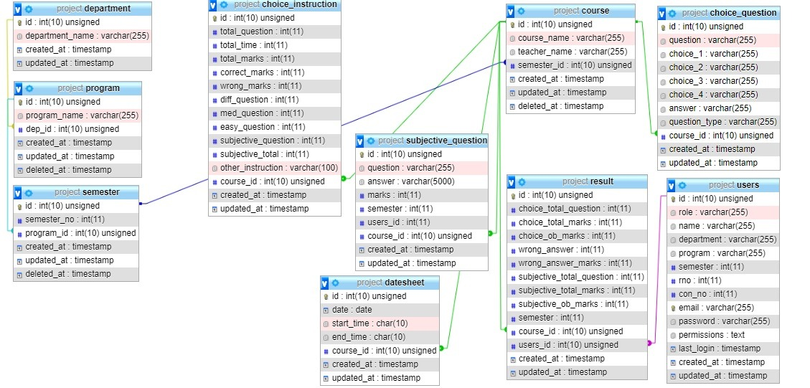

attributes

**Independent tables with their attributes**

Table 3. 2 Independent tables with their attributes

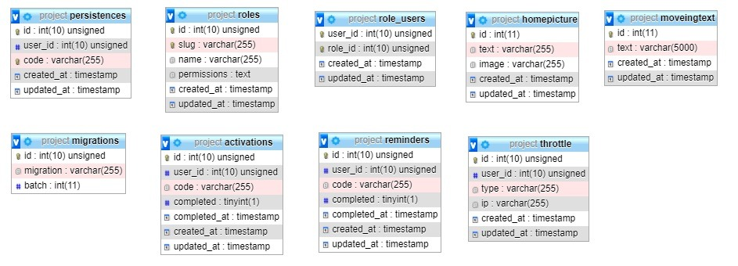

# CHAPTER 4

# IMPLEMENTATION

## 4.1 Introduction

The OECS software is successfully developed in this project. OECS is designed for the convenient of university students for online exams, quizzes. After the successful implementation of OECS this system is fully designed according to the user requirements.

## 4.2 Development Tools and Environment Used

### 4.2.1 Tools Used

1. Html

2. CSS

3. JavaScript

4. jQuery

5. Xamp database

### 4.2.2 Environments Used

1. PhP Laravel

2. Visual studio

### 4.2.3 Training

It is necessary to run software when you know about its uses. A well-designed software is failed or success it depends upon its users. A well design system needs a well instructor to aware the user about the uses of the system.

### 4.2.3 Hardware and Software Selection

All the database management systems require precise clarification of software and hardware specification. The current and future needs of the present system should be taken into consideration while implementing this system.

## 4.4 Features of Web Application

A web application has short development cycle and can be made by development teams. Web applications have many potential benefits such that open source freely available on world wide web. Some important features of our proposed system are the following.

### 4.4.1 Notification System

The benefits of a notification system are we can set up our system so we can be notified immediately if the key measurement moves beyond standard deviation. This will allow us to quickly isolate the situation, analyze it and take the necessary steps.

### 4.4.2 Mobile Friendly

We must make our web application responsible. In this context, responsiveness means that our system display needs to be automatically adjusted to whatever screen is being viewed. Another important issue is to build our application system so that it loads quickly on any device.

### 4.4.3 Analytics Dashboard

Analytics is the result of taking data and analyze it via a predefined process. Analytics for our site can show us that how many visitors we had in one day and how many bounce, how many of them turn into leads. Analytics dashboard is also used for different context like social media, digital marketing, ecommerce, SEO, UX.

### 4.4.4 User Rights Management

There are three types of permissions user, role, and access. These three types are commonly found within software project management. These permissions find out that what information’s client can view. And what can edit within the software.

## 4.5 Tools Used for Developing Web Application

The web application for developing, we can use windows PC, Mac, or Linux. The web application tools that is freely available on world wide web and easily download and used.

The following is some tools which is used in our proposed system.

* CMD
* Visual studio code
* Xamp server
* PhP Laravel
* Browser

# CHAPTER 5

# USER INTERFACE

## 5.1 Online Exam Conduction System User Interface

Various tools have been used in this application described in chapter no 2. And finally, we developed a fully functional proposed application based entirely on system requirements and design. We have implemented different features in our application and these features are described below along with the relevant screenshots.

## 5.2 Front End

### 5.2.1 Front Page

Front page of OECS is consists of login and register. The home page consists of movable/dynamic picture where admin can change it.

Figure 5. 1 Front page of the OECS

### 5.2.2 Login

Login interface in OECS is used to login here. Admin, HOD, teacher and students are login in this interface.

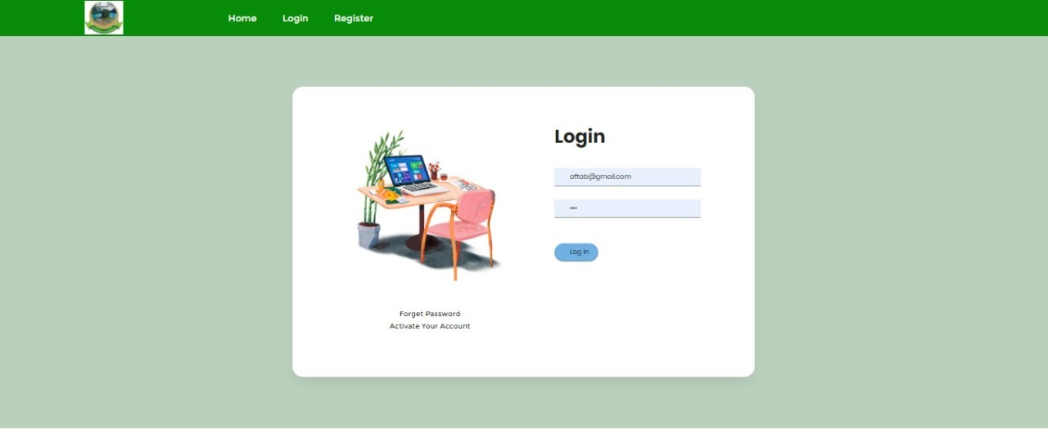

Figure 5. 2 Login of the OECS

### 5.2.3 Register

It provides registration for admin, HOD and teacher.

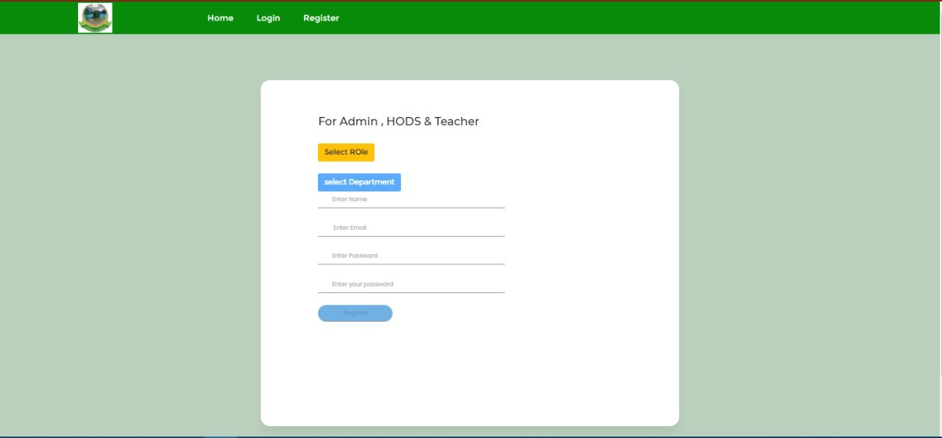

Figure 5. 3 Registration of OECS

### 5.2.4 Admin Sidebar

When admin login then admin can upload home page picture, upload text for home page. An admin sidebar admin will be providing activation for HOD emails. Admin can add programs in university and can add departments.

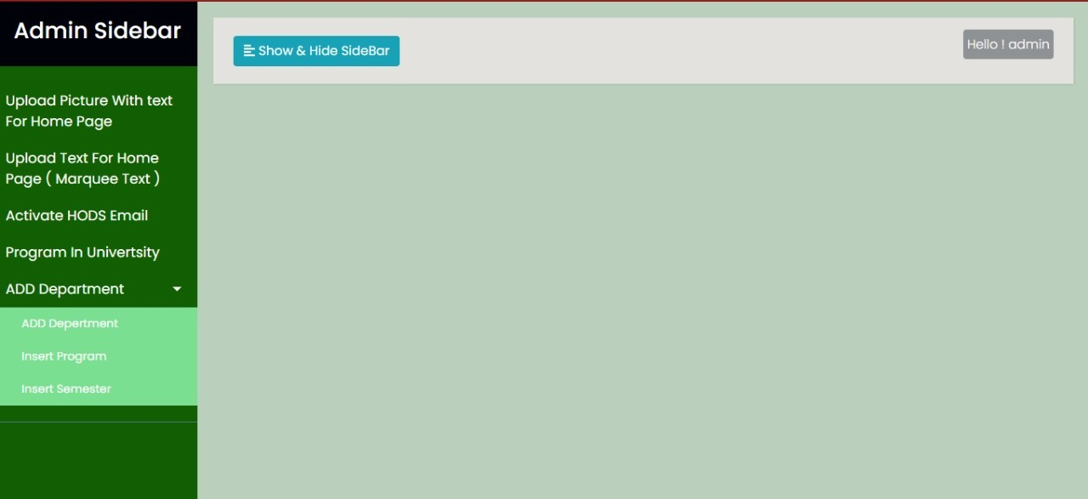

Figure 5. 4 Admin Sidebar of OECS

### 5.2.5 HOD Sidebar

HOD sidebar in our OECS, it can provide activation for teacher’s account. Provide course insertion. Import the students, provide datasheet and promotion of the students by semester.

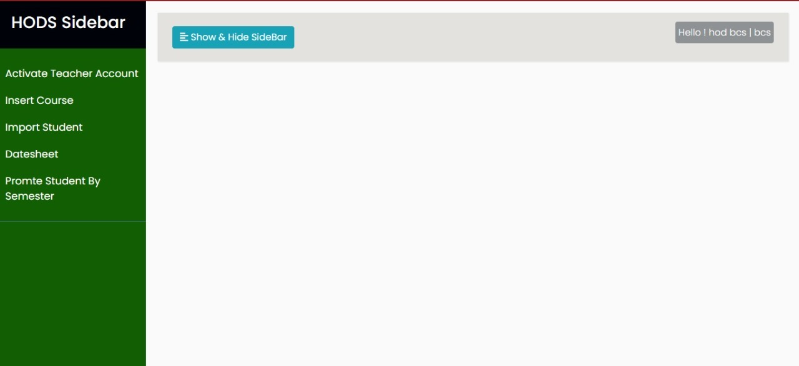

Figure 5. 5 HOD Sidebar of OECS

### 5.2.6 Teacher Sidebar

Teacher sidebar of OECS is consist of upload paper and instructions, check paper and check result of own course.

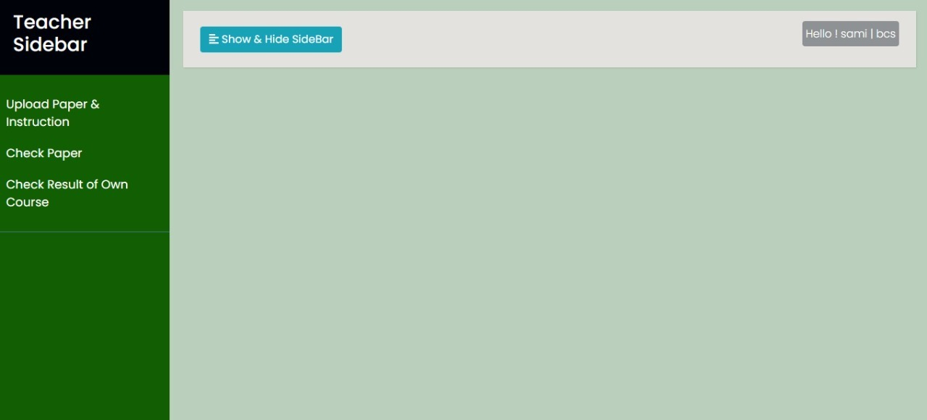

Figure 5. 6 Teacher Sidebar of OECS

# CHAPTER 6

# TESTING

In this chapter we discuss the testing phase of this OECS software.

## 6.1 Web Application Testing

Web application testing is specially used for testing the proposed system. In web application testing functionalities, interfaces, capabilities, usability, and performance of the web application are tested particularly.

### 6.1.1 Unit Testing

It is a small testable part of a web application. Unit testing method is used to which a single unit of an application is examined to determine whether these units are fit for individual use.

### 6.1.2 Integration Testing

By integration system first we collect all the units of a web application and after that the collected unit is test as a group. The main purpose of integration testing is to define the defect and faults between the interactive units of the software.

### 6.1.3 User Interface or System Testing

The home page, menu, icons, buttons, and other interactive elements of our proposed system are checked during the user interface. In user interface method the user does not consult with directly that is only the interface of the application system is visible to users.

### 6.1.4 Acceptance Testing

This method ensures the flow of the user application when the user accept the request when the functionality of the proposed application/system and its features are work properly. And this is the final stage of testing any application.

In our OECS case we have checked and particularly all the above described testing methods for our (OECS) online exam conduction system. It is worked according to the user actions. Finally, we have tested the whole (OECS) online exam conduction system that meets the requirements of the user.

The block diagram of the following testing methods is as follows.

Unit Testing

System Testing

Integration Testing

Acceptance Testing

Figure 6.1 Testing methods

We have many ways to check this web application, but we use black box testing for our OECS software.

## 6.2 Black Box Testing

Black Box Testing is the method of software testing that tests the functionality of the utility according to features also called behavioral testing. The independent testing team usually tests such software on attesting life cycle. This testing technique can be applied to every level of software testing including unit, integration, machine, and gravity testing.

For registration of user we must need to save all information of user in database for further use. If user submit his registration form without enter data in each input text box, the software will not accept his request and give response and mention his text box is required with error message show in figure 6.2.

Figure 6.2 Registration page with error message

The login, register and forget password process depend on email if user enter wrong email these process does not work. We need to check user email for these processes. If user want to login, they must be entering correct email. Then software checks the user email if email is in correct type software allow them for next step otherwise the software will be show wrong email message (Must Be Email Type) show in figure 6.3

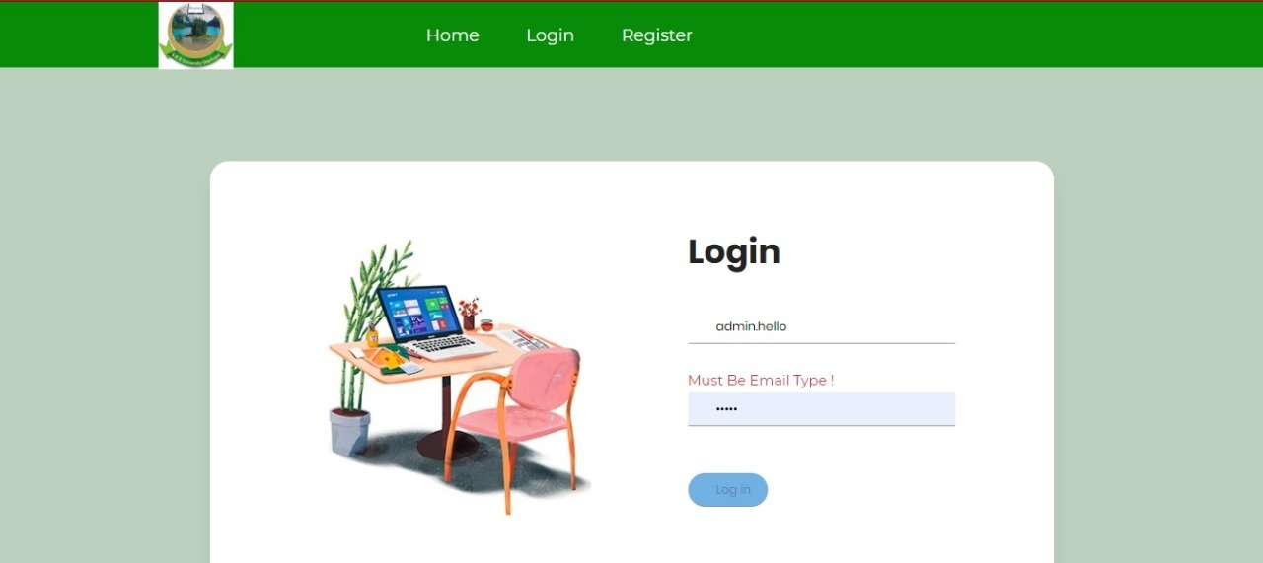

Figure 6.3 Submit wrong email error

In entering of data, we have two types of data string and numeric in some places we need only string type of data for example Name, department name, paper name etc. In string type of data, the software check that the user enters string form of data or not if the data not in the string form the software show the wrong input data show in figure 6.4

Figure 6. 4 Integer type of data error

In some places we need only integer type of data for example semester, contact number, Roll No,

etc. In integer type of data, the software check that the user enters integer type of data or not if the data not in the integer form the software show the wrong input data show in figure 6.5.

Figure 6. 5 String Type of Data Error

# REFERENCES

[1] <http://en.wikipedia.org/wiki>

[2] <https://www.youtube.com>

[3] <https://laravel.com/docs/7.x>

[4] [https://www.studentstutorial.com](https://www.studentstutorial.com/)

[5] https://www.w3schools.com

[6] <https://stackoverflow.com>